**WORKFLOW FOR INSURANCE AGGREGATOR**

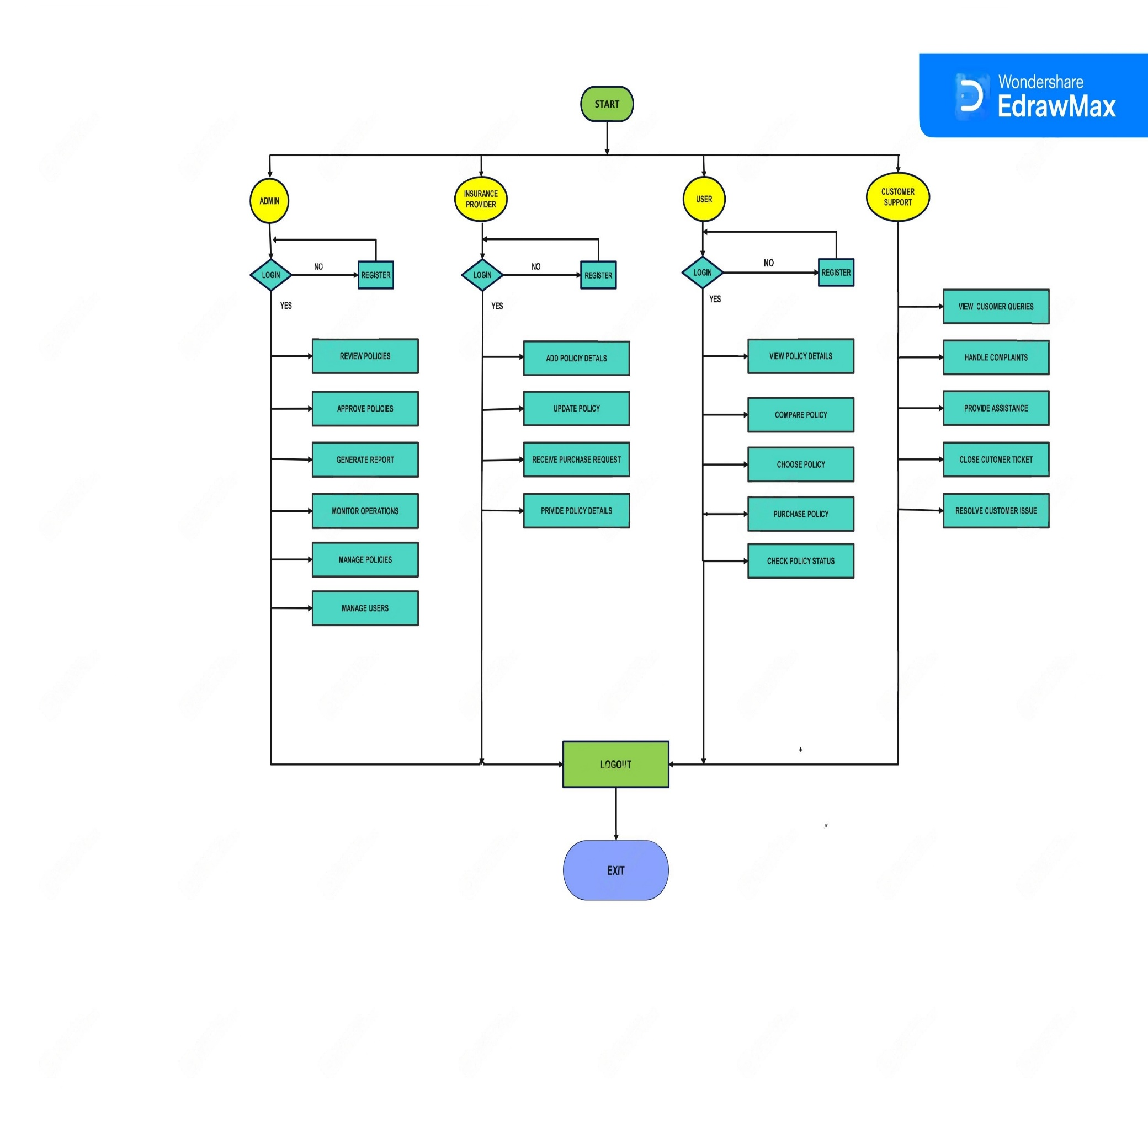**APPLICATION**